**THIN AND THICK PROVISION**

Thin and thick provisioned disks offer similar storage capabilities, but they do have differences. Thin disks allocate storage space on demand up until the disk reaches its maximum required amount, while thick disks allocate the entirety of required storage space at the time of creation.

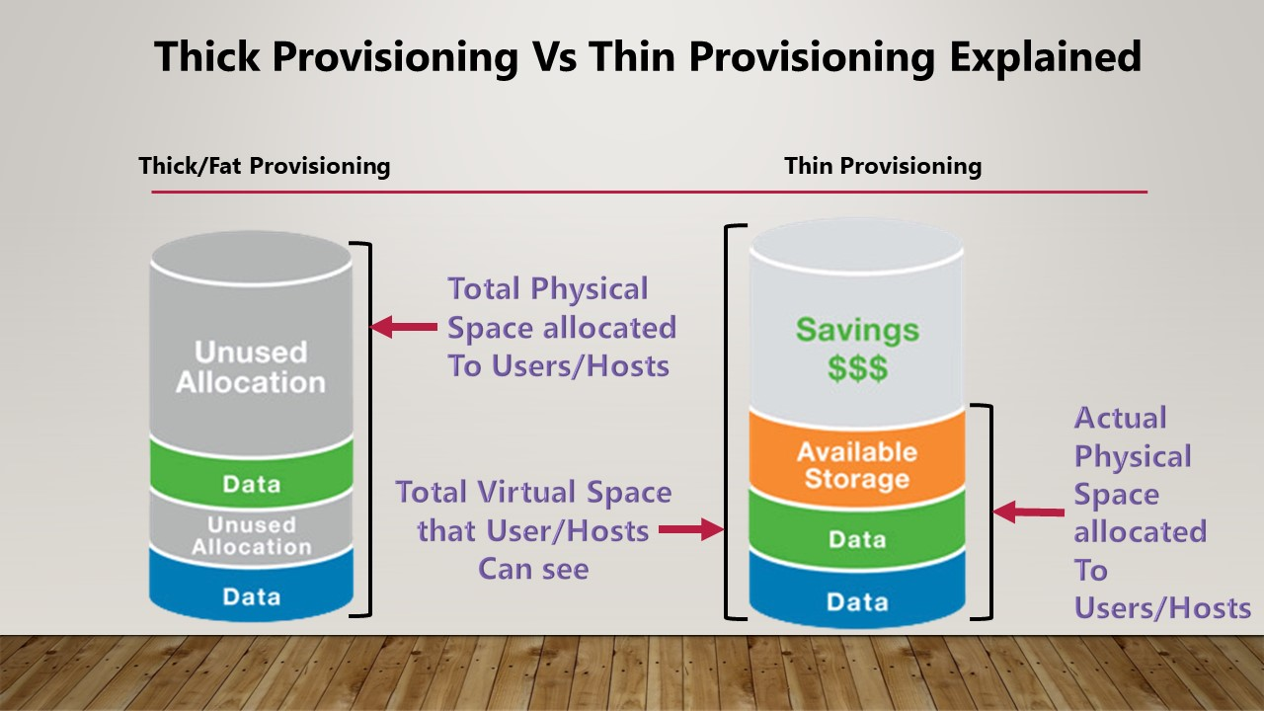

In thick provisioning if we allocate a space to it even if it not consumed it will occupy the space no other services or others can’t use it whereas in thin provisioning even if we allocate the space also, it won’t consume the whole it will use the actual usage value

<https://www.youtube.com/watch?v=nLjeuXUP4pw>

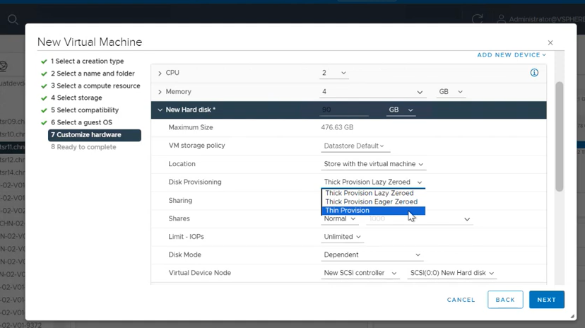

By default thick provision Lazy zero

**In thick provision IOPs is good**

**Max everyone will go with thick provision only if there is a storage constraints then onlyw e can go with thin provision however IOP is not effective in it**

**To Convert Thick to Thin provision**

**We can easily do it by storage migration**

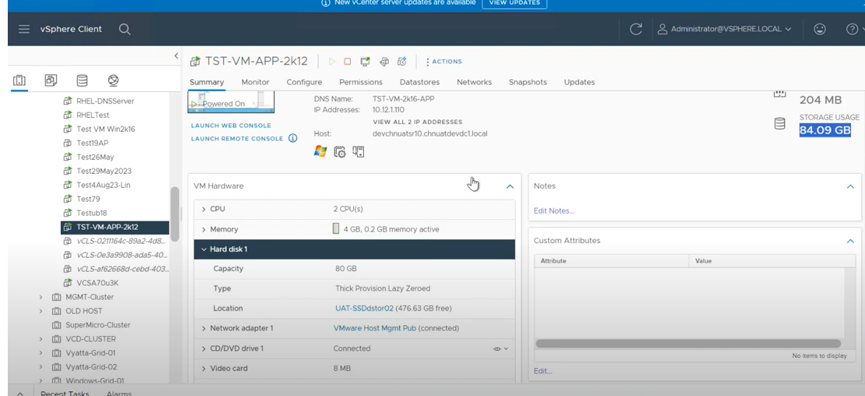

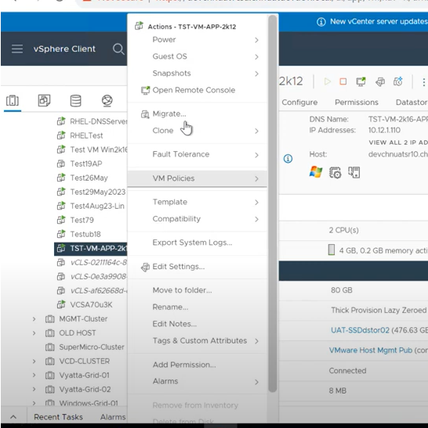

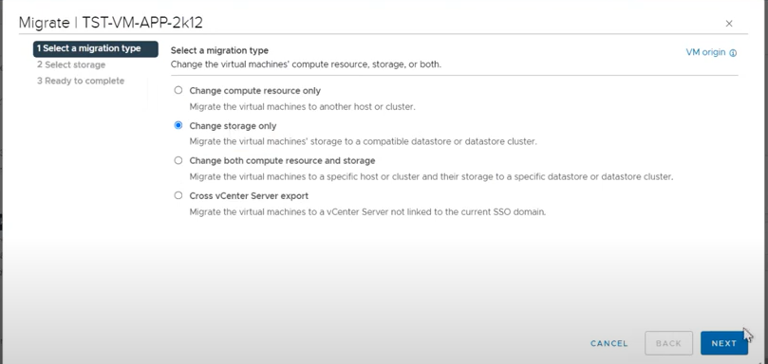

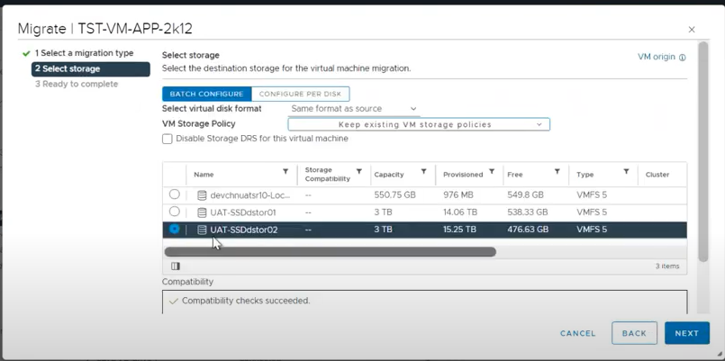

**Change the storage type**

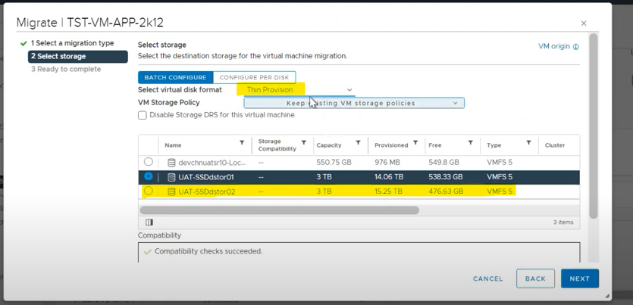

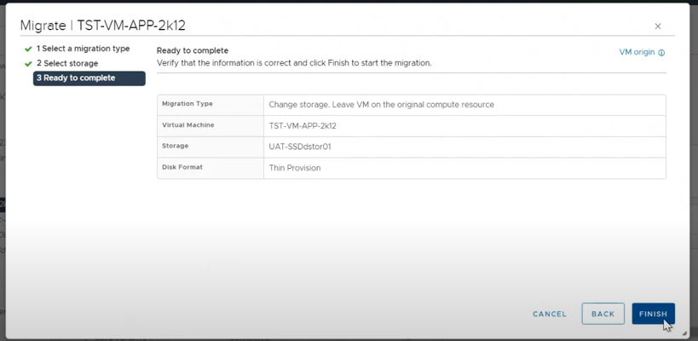

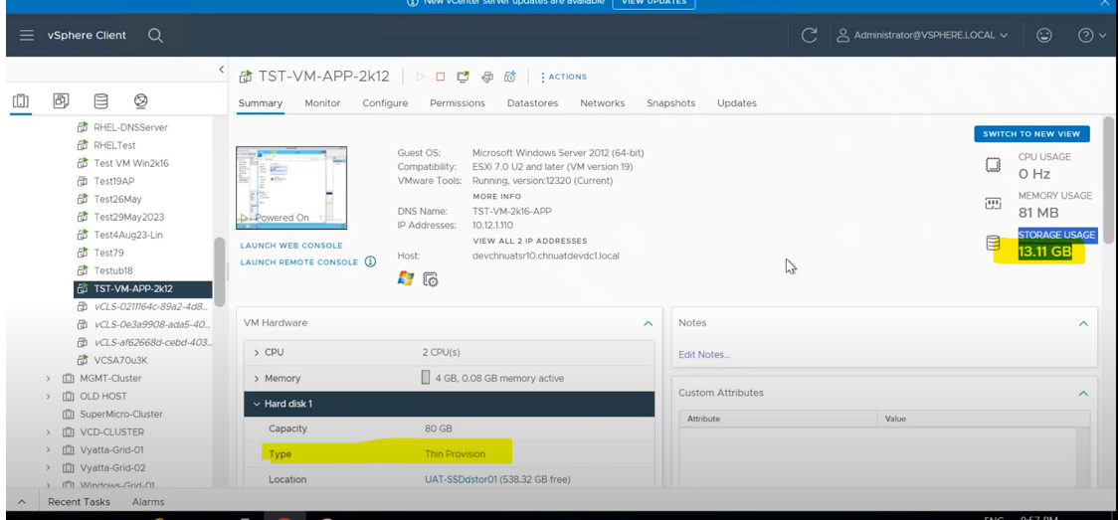

**THICK LAZY ZERO VS THICK EAGER ZERO**

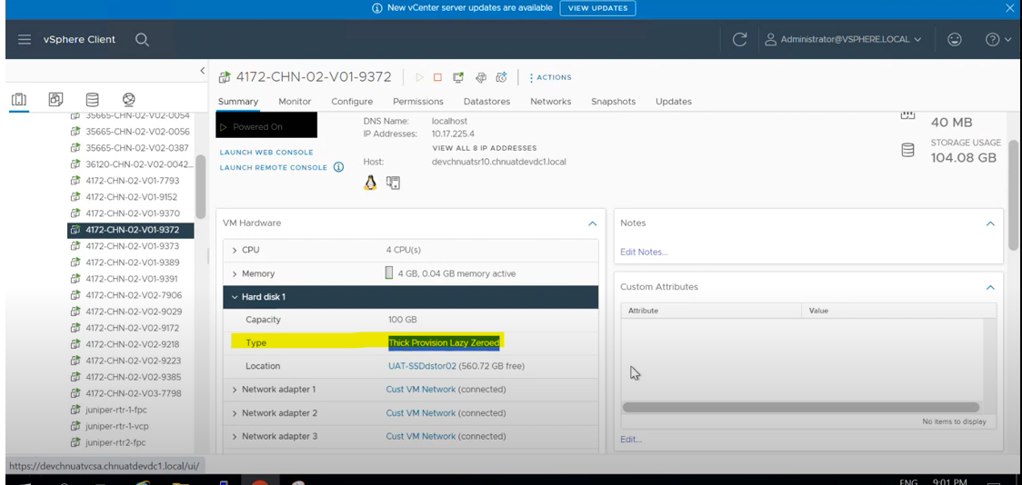

For lazy-zeroed thick virtual disks, the data store is zeroed out on demand as data is written. In contrast, eager-zeroed thick virtual disks are zeroed out fully at creation time. Because of this difference, eager-zeroed thick virtual disks are generally considered to offer superior performance.